Install Jenkins in AWS EC2 instance using command prompt on windows machine

1. Create EC2 instance on AWS
2. Use command ssh –i “location of key-value pair” ubuntu@public ip address

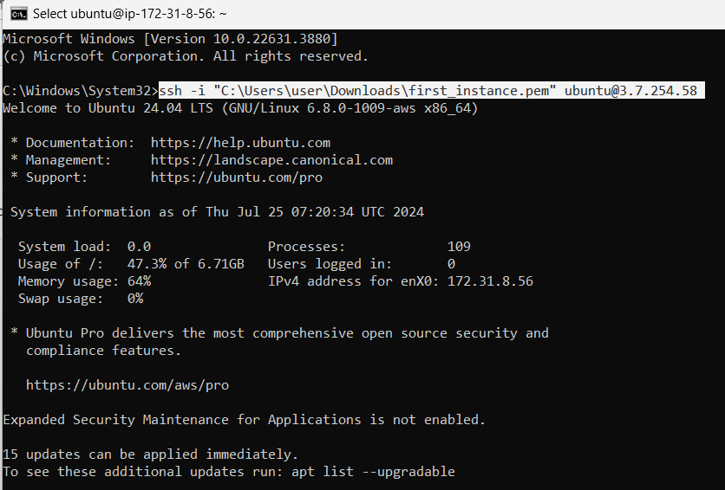

1. Update using sudo apt update

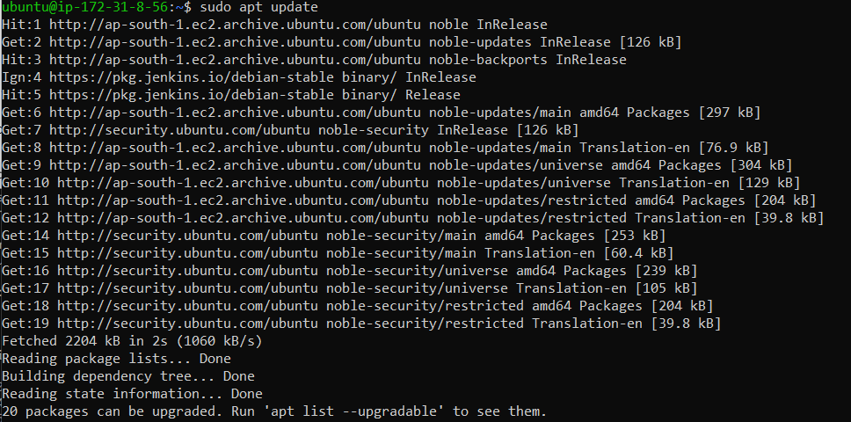

1. Install Java – sudo apt install openjdk-17-jre

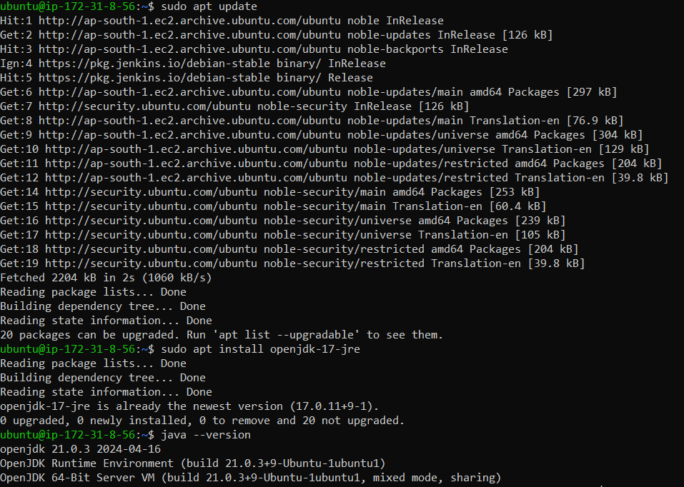

1. Search Jenkins download on browser and copy the command for installing Jenkins on Linux

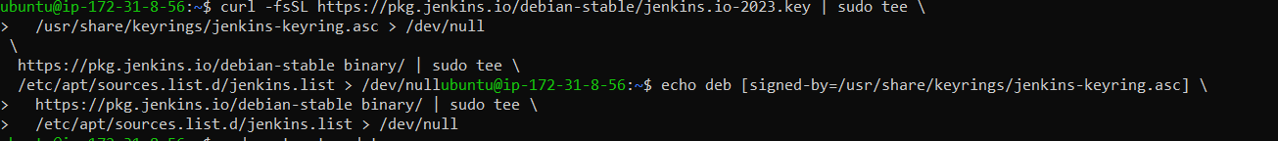

1. Use sudo apt-get install jenkins

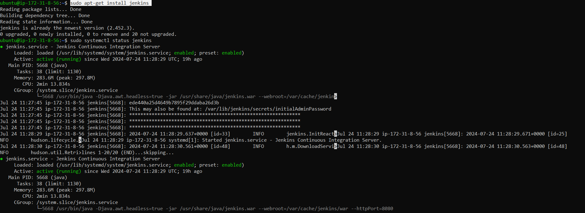

Check if Jenkins is active

1. Change inbound security rules on AWS EC2 instance to allow port 8080. Then use <http://public_ip_of_EC2:8080> on browser. The below page appears

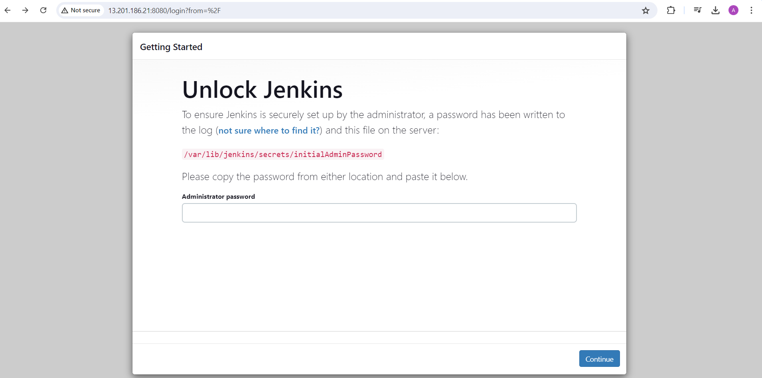

1. Type sudo cat <the path mentioned in above screenshot> to get administrator password and click continue.

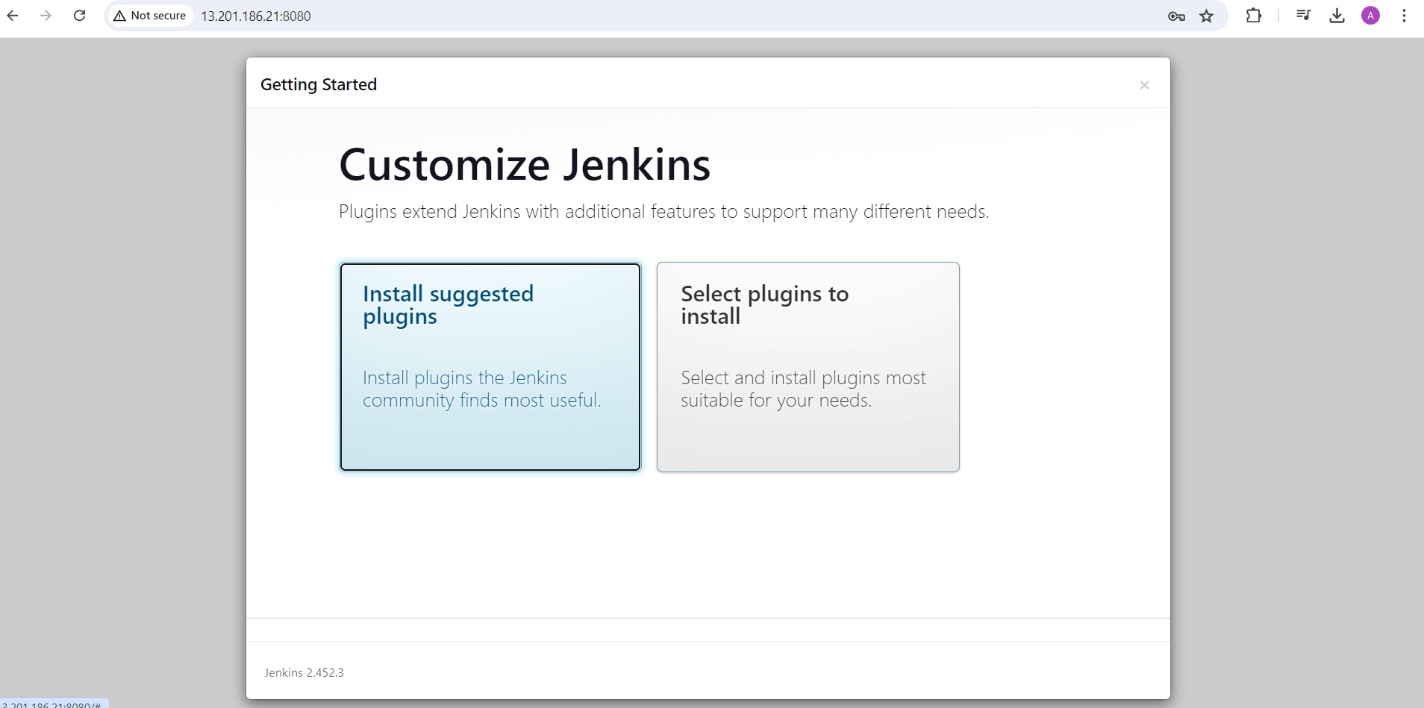

1. Jenkins is running successfully on EC2 instance.